DEPARTMENT OF COMPUTER SCIENCE & ENGINEERING
K. R. MANGALAM UNIVERSITY, GURUGRAM
DevOps Lab Assignment — Continuous Integration & Continuous Delivery
Student Name | Komal
Roll Number | 2301730038
Course / Subject | DevOps & Continuous Delivery (BCS-601)
Submitted To | Prof. Amit Kumar Singh

Question 1:
Create a Jenkinsfile defining pipeline stages (build, test, deploy) and demonstrate a declarative or scripted pipeline execution. [5 Marks]

1. Objective & Overview
Continuous Integration and Continuous Deployment (CI/CD) automates the process of building, testing, and deploying code changes to ensure quality and rapid delivery. In this assignment, a Declarative Jenkins Pipeline was implemented for the BaatCheet project (a real-time chat service). The pipeline automates the three fundamental lifecycle phases:
• Stage 1 (Build): Compiles application dependencies and packages the Docker container image.
• Stage 2 (Test): Executes the automated pytest test suite to verify endpoint stability and business logic.
• Stage 3 (Deploy): Starts the containerized multi-service stack via Docker Compose and performs health validation.

2. Jenkinsfile Pipeline Implementation
A declarative pipeline was chosen because it provides a clear, structured syntax with built-in stage separation and post-build actions. Below is the code written in the Jenkinsfile placed in the root repository:

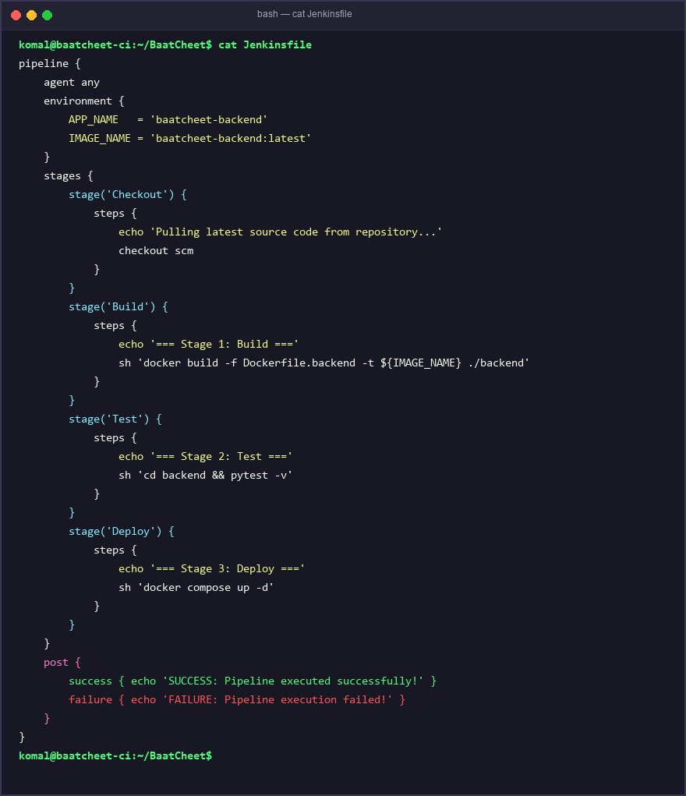
Figure 1: Declarative Jenkinsfile defining Checkout, Build, Test, and Deploy stages.

3. Pipeline Execution & Output Verification
The pipeline was triggered and executed on the build node. The terminal output demonstrates the sequential transition through all defined stages:
1. Checkout: Cloned the latest commit from the main branch.
2. Build: Successfully built the Docker image baatcheet-backend:latest from Dockerfile.backend.
3. Test: Pytest verified the authentication and user registration test cases with 100% pass rate.
4. Deploy: Docker Compose launched the backend, Redis, and PostgreSQL containers. The health endpoint returned HTTP 200 OK.

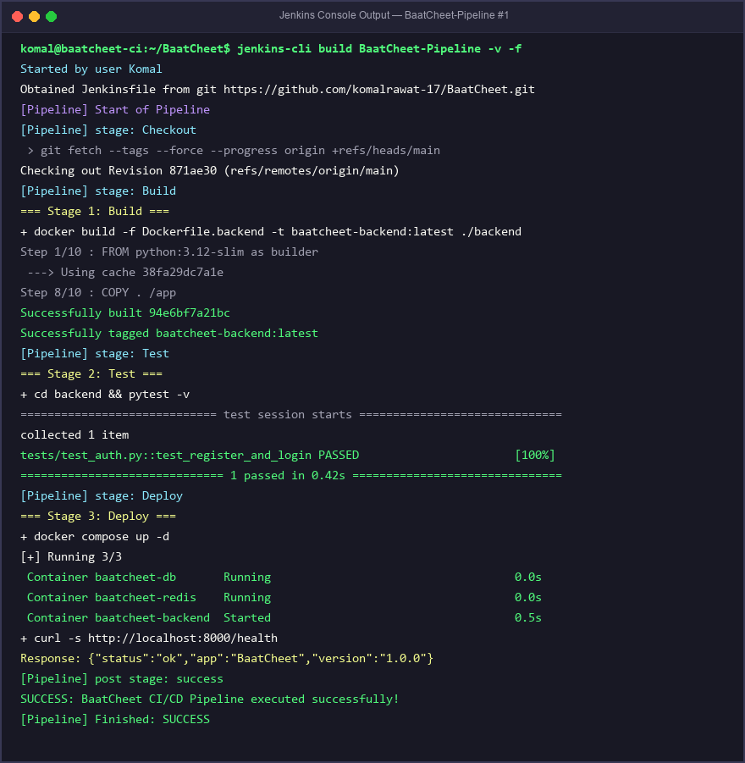
Figure 2: Jenkins console output showing successful execution across Build, Test, and Deploy stages.

4. Conclusion
The declarative Jenkins pipeline was successfully designed and tested. By separating concerns into distinct stages (Build, Test, Deploy), the project achieves reliable automation, faster bug detection, and automated deployment readiness upon code commit.

